FILM FESTIVALS

SPECIAL REPORTS

by Amanda Perkins & David Bryant Perkins
My Dog - Music Video
Cedar Breaks ® Band

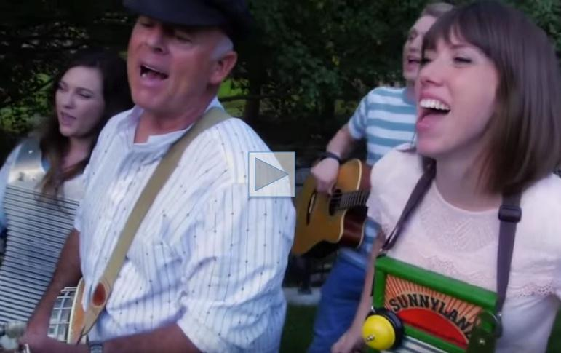

Alright. I know what you're thinking. We've gone to the dogs.
Well, perhaps it looks that way, but we assure you, having two 'dog' features back to back happened purely by coincidence. Really. Besides these are very different films. Actually - we are proud to say - this is the first music video we've every featured. So you are witnessing history. For us, for the festival, and for the Cedar Breaks Band.
You see, these guys and gals and kids and dogs won best music video at the International Family Film Festival, and this isn't the first time. Back in August they brought home the trophy for the Best Country Video at the World Music & Independent Film Festival in Washington DC....Congratulations, guys & gals & kids & dogs....
Yes..dogs...they are, after all, a part of the family too (I'm slowly working into a theme of the video now) and it is this story line that is wonderfully spread as a reminder and lesson. Plus, this really is a music video you can share with the entire family, and sing along with too!
Now for those of you who are tone deaf, let me tell you why these guys & gals & kids & dogs won all these festivals. This group can sing. I have not heard interactive harmonies that come close to this since ABBA. And in a way, ABBA had it easier...those girls only had to harmonize with each other while the Cedar Breaks Band have six individuals simultaneously match pitch, tone, notes, and chords. No easy feat, I assure you....
So gather the family around - guys & gals & kids & dogs - press play and have a nice sing along. Or just listen when you come home after a hard day....how can you not feel good after listening to some foot-tapping, head nodding, happy harmonies from such a song, anyway? Especially when there's a banjo there to lift the spirits...

