Press Release Cedar Breaks screens two films at the 2016 LDS Film Festival
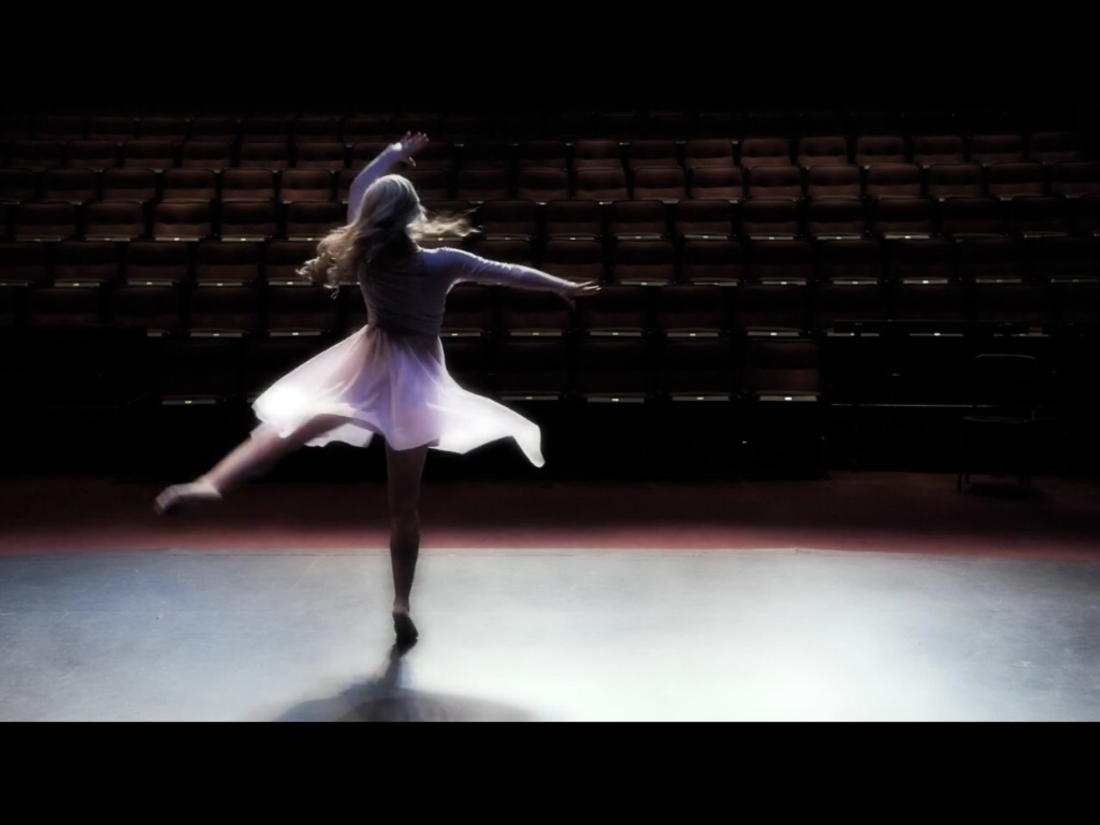
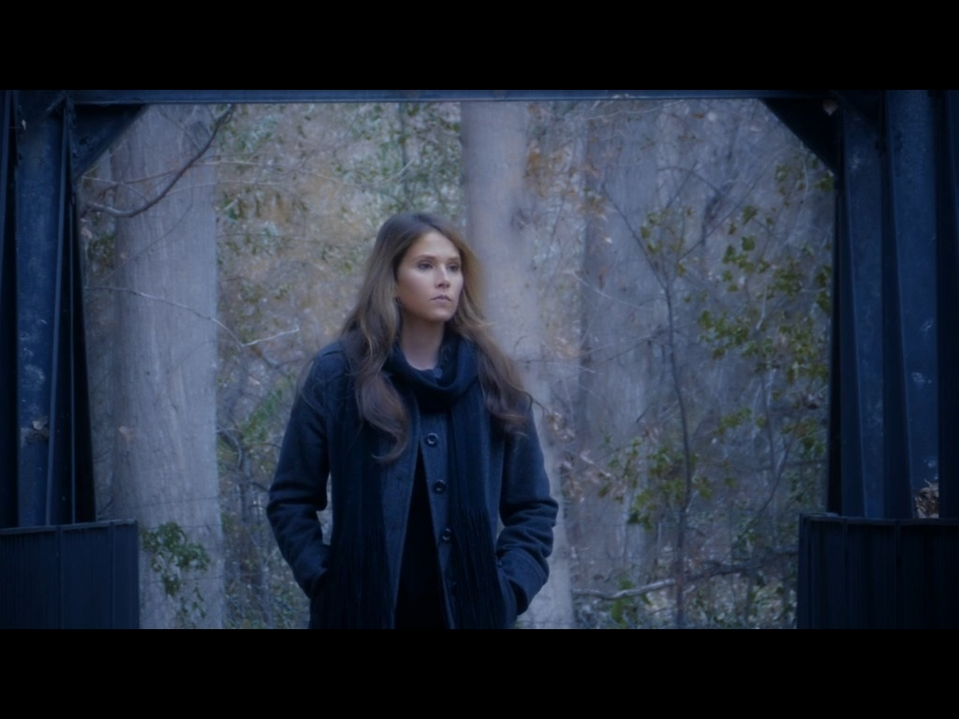

Don’t Go
Light

Cedar Breaks is known for its original music videos using the natural beauty of Utah and solid crafted songs featuring flowing harmony and strong messages of faith, family, and heritage.
Their films have been screened in music and film festivals across the country including the International Christian Film Festival, the World and Independent Film Festival, and the International Family Film Festival. They have a number of wins in 2015 including, Best Country Music video and Best Short video for "My Dog", and best Gospel Song in a music video for "Light".
According to band member Mike Ericksen the bands success is centered around, "the demand for good family friendly content built around good music that inspires. We have also been impressed with the number of Christian film festival who have had us back several times, it seems as though we have found common ground in our themes that can help us look past our differences and center on strong family values that foster tolerance and understanding."
The first film featured at this years festival, "Light" suggests that we take the time in our busy lives to notice those in need and then take the time to give of our light and the substance that we been given?
The story is told through a dancer racing to an audition and through a compassion moment she is not able pass a stranger in need even though it might take the sacrifice of her not making the audition.
Byu dancer Chanel Kostich is featured in the film with her original choreography. She has performed with the band in videos several times over the last 3 years.
In Mike's words "In our thoughts her selfless act in the film already alined her with the Band and the theme of the song, and she joins us metaphorically as she performs her dance the ripple of kindness grows." He went on to say, "Light is a special song that was written under very special circumstances and contains an important message for our time." The song's origin was also highlighted in the historical novel "Upon Destiny's Song" of which Cedar Breaks was involved in with their music. Michael Gibbons, sings lead on the song with Rebecca Croft and Diana Roger Glissmeyer on harmony. : "Light" was written by Mike's brother Greg Ericksen.
The second film "Don't Go" simply allows the viewer/listener to get involved in the message of the song by viewing a young lady on a simple walk through some woods on a fall day. The message is accented by simple facial expressions and body language to express, sadness, loss, remembrance, reflection of past joy, strength, determination and faith. Mike added, "We wanted to see if we could with the power of our music and simple walk of reflection take the viewer on a journey of emotions." Actress Shaunee Lamb, who has been in several Cedar Breaks productions stars in the video. The song was written by band member Rebecca Croft who sings lead.
The original photography and editing was done by Norm Bosworth of BCI video, who does all of Cedar Breaks films.
The LDS Film Festival will run March 2-5 at the Scera Theater in Orem Utah. "Light" screens at 5 pm Thursday March 3 and "Don't Go" at 5 pm Friday March 4th. For more information go to www.ldsfilmfestival.com.
Find more about Cedar Breaks Band at these web sites:
Www.cedarbreaksband.com
Www.upondestinyssong.com

