Press Release April 24th 2017

Cedar Breaks ® Band Selected for the International Christian Film Festival

Cedar Breaks Band is selected to be a part of the International Christian Film Festival with the music video "Believe". Chosen to be screened from over 500 film entries. "Believe" features Rebecca Croft and is a treatise on freedom and the awareness of what we have been given in the blessings of liberty. How we should be tolerant of all cultures, genders, religions, and races and that our rights are to be remembered and spoken of.
A very timely message for our country.
The high energy of this song makes the power of the words move deep into the mind with expressions that you will undoubtedly feel. The film deals with social issues and the blessings of our freedom of choice, and the celebration of the opportunities in our country.
The Festival is held at the Wyndham in Orlando Florida May 4-6, 2017

Believe https://www.youtube.com/watch?v=YhfvtTEwmRA

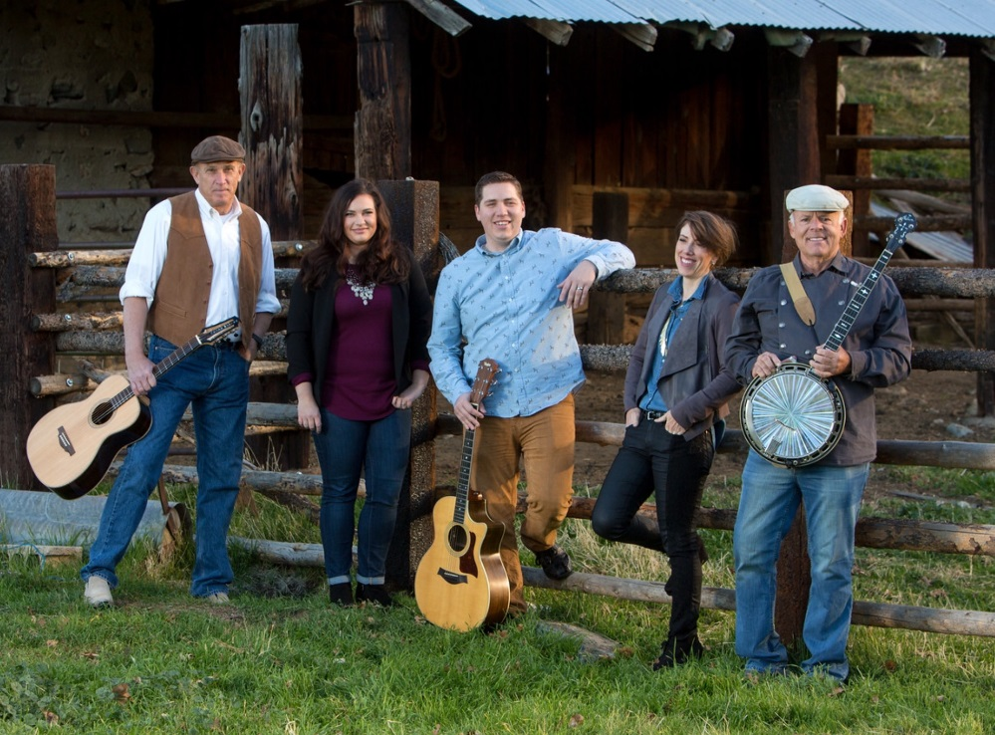
Recent awards

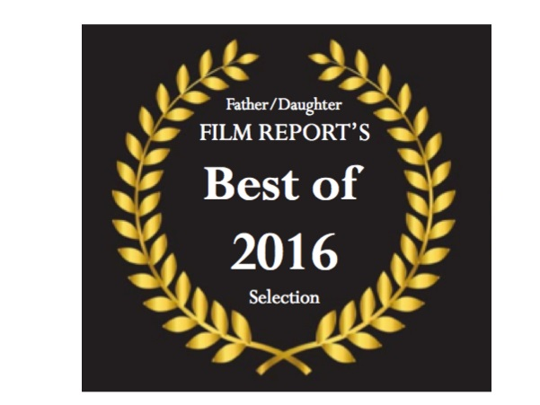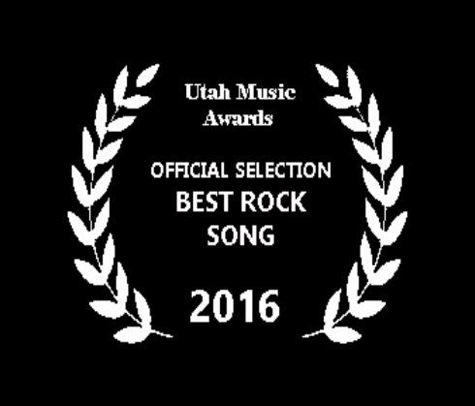

The Utah Music Awards nominated two songs by Cedar Breaks © Band
Cedar Breaks Won “Best Rock Song”

Cedar Breaks wins "Best of 2016" from the "film Festival Today" Reporters, Father/Daughter Team for "My Dog".

Cedar Breaks © Band crosses the genre line with two very different songs, one "folk/country" and one in the "rock" category at the 2016 Utah Music Awards presentation September 17th in the Covey Center in Provo, Utah. http://www.theutahmusicawards.com/
Though the basic trend of Cedar Break's © music is labeled “New Age Folk" the band is very diverse and loose with that designation, presenting songs with rock, blues, bluegrass, and even gospel leanings. They combine strong and interesting harmonies with diverse settings of instrumentation including Classical guitar, rock guitar, violin, piano, banjo, and drums.
The members of the band include; classical guitarist Mike Ericksen, guitarist and pop singer Michael Gibbons, classical singer Rebecca Croft, pop singer Diana Rogers Glissmeyer, and banjo player Keith Behunin.

The first song in the Utah Music Awards competition is, "Ayre", which was just completed in July of 2016 and is an energetic rock song with strong guitars, vocals and drums. “Ayre” will be released in September as a single and is part of a new album that Cedar Breaks © is working on called "Myst, Thread of Life" scheduled to release in 2017.
The Band gets asked a lot about the meaning of the name "Cedar Breaks ©". So “Ayre” was written for that reason and as a namesake piece. It's a bit of a “look up from the device and get back to nature and the Spirit" song. A band member commented, “We love cell phones and devices but there is whole world out there waiting to communicate with us, if we will just listen." The Band loves to showcase the beauty of their state in their films and they are excited to demonstrate the strength of Utah’s diverse culture built around the blessings of freedom. When asked about the song meaning, one replied, “When you stand at the cliffs of Cedar Breaks © if you look up at night or down in the day, either way you can see millions of years in the past as well as the endless possibilities in either direction. You can look across the vast waves of green cedars that are now, and realize in the “Myst” of all that time that you have choices to make that will affect generations. You realize that you must step forward with meaning and intent.”
The band plans on releasing "Ayre" next month.

The second song "My Dog" was released as a single last year and features a touching message about the value of family pets with a touching folk/bluegrass feel. The song is inspired by the loss of the family pet of one of the band members. The song and music video have already won for "Best Country Song" at the World Music and Independent Film Festival in Washington DC and for "Best Family Music Video" at the International Family Film Festival in Hollywood.
"My Dog" was also made into a Children's Book last fall by Guardian Angel Publishing in St. Louis. One commented, “Perhaps we have finally answered the lifelong question, as to whether dogs go to heaven…… and that's important”.

Though Cedar Break’s © message is strong and deep, this song shows that they don't take themselves too seriously and have a lot of fun.

"My Dog" music video features all band kids, and a lot of puppies."
All members of Cedar Breaks © have individual music and performing careers, and they come together as Cedar Breaks © Band as a way to present top quality media that they hope will make a difference in the lives of others with the use of stories and themes about faith, family, and heritage.
The interesting combinations of style, age, and different musical back grounds of the band members has produced a sound that has been noted as being "fresh, distinctively different and timeless".
What's really unique is the ways that they have found to spread their message. At this time they are not a touring band because of a commitment to their young families. In the five years that they have been together, they count 10 babies. You can see family all throughout their films as well as many times on the film sets or in the recording studio. They are committed to the message that they send out and they are quick to point out that it costs a lot less to have family members part of the production.
Still Cedar Breaks © has done a lot of programs and concerts over the last five years usually with just one or two of the band members at a time, but rarely with all 5 members together other than to practice, work in the recording studio, or presented on the screen. The last summer found their presentations and concerts in Iowa, Wyoming, and Utah. They have been able to combine our message with live songs from one or more of the band members and then introduce the band with some of their videos.
They have put their strong message and music into books, films, documentaries, speaking engagements, and music videos that have gone all over the world.
They also have a talented naturalist photographer that they work with, Norm Bosworth from BCI video........ And they have a dancer, BYU student Chanel Kostich.
There is also an interesting inter-faith part of their story. The Band’s music and videos have also been played at many Christian music and film festivals across the country and even winning some. One band members pointed out, “We have so much is common and societal goals with other faiths, so we want to find ways to celebrate these and to work together. Though the band presents its media as non-denominational they bring the spirit of who they are to the world. Do they know Mormons have music in their festivals, of course? But Cedar Breaks © believes that their message can transcend the different faith traditions"
Cedar Breaks © Band is part of Empath Media LLC

My Dog https://www.youtube.com/watch?v=wdpR773wLLQ

The mission statement of the band is:
"Do not trust your good intentions.
Trust your willingness to act.
Even in the face of challenges.
Consider all those that have gone before.
Know the you that is now.
For today we change the world.
And leave behind a gift, redeemable.
To those dearest to our hearts."

Contacts:
Mike Ericksen
Empath Media LLC
801-560-0335
ericksen.empath@gmail.com
www.cedarbreaksband.com
Band manager, Rebecca Croft

